**E. Anderson CPM PERT Examples (Healthcare)**

**SOLUTIONS**

**CPM**

The U.S. process for producing vaccines, slightly simplified. The tasks involved, along with task times and precedence requirements, are given below.

TASK DESCRIPTION IMMEDIATE TASK TIME

PREDECESSORS (in weeks)

A Identify Strains (CDC) __ 1

B Prepare hybridized viruses (CDC) A 3

C Verify hybrid viruses (CDC) B 3

D Distribute hybrid viruses to mfgrs. (CDC) C 2

E Develelop testing reagents (CDC) C 11

F Set up manufacturing (mfgrs) D 4

G Manufacture vaccine (mfgrs) F 6

H Test vaccine in house (mfgrs) E, G 2

I Vaccine packaging and release (mfgrs) H 3

J Clinical Trials (mfgrs) I 4

K Review and Release (FDA) I 5

1. Draw the network diagram for this project. How long will it take to complete the project?

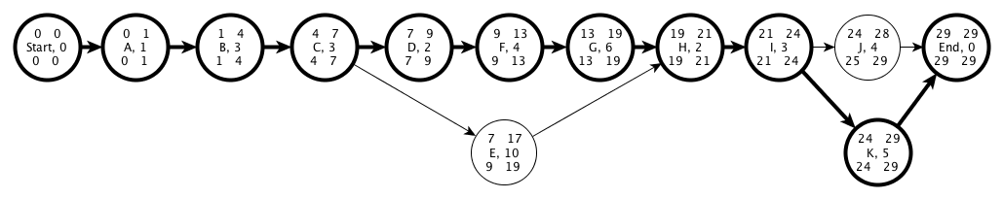

**29 weeks**

1. What are the slacks for each activity? What is the Critical Path?

**CP: Start-ABCDFGHIK-End. Slacks for E is 2, and for J is 1.**

1. If task E is delayed by four weeks (not uncommon in practice), how is the project completion time affected?

**The slack on E will be violated by 2 weeks, so the project will take 31 weeks to complete.**

1. If task J is delayed by one week, how is the project completion time affected?

**No effect, although now you do have two critical paths. Start-ABCDFGHIK-End and Start-ABCDFGHIJ-End**

1. You have been given some money that you may use to speed up any one task in the project. Explain how you would select a task to speed up.

**Anything on the CP would be find. Typically, though, you’d look at either (a) the least expensive task or (b) tasks A, B, or C since they occur prior to both of the near-critical paths as well. Hence, if E or J violate their slack, money spent reducing activity time on A, B, or C will still have had a beneficial effect.**

1. You notice in fact that task G can be split into two tasks, “manufacture lot 2” (task G1) and “Manufacture batch 2” (task G2), each of which takes 3 weeks. This causes some change in the CP diagram as shown below, splitting the testing and packaging into two separate, shorter tasks as well. In addition, the clinical testing can be done once the first batch is packaged, so the second batch does not have to wait on clinical trials and FDA review and release.

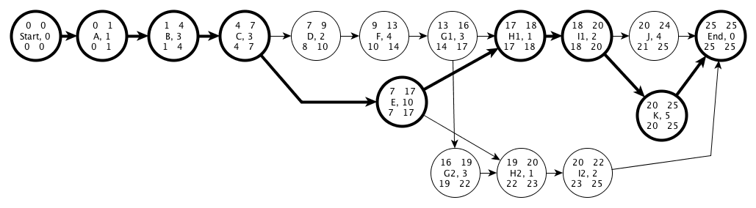

What does this tell you about the effect of aggregation of tasks on managing a project? More specifically, what are the tradeoffs involved in splitting a task?

**Separation of tasks gives you more flexibility in scheduling and potentially a shorter project duration. In addition, the critical path can shift. In this case, nodes D, F, and even G1 are no longer on it. The trade-off is that the time to do H1 and H2 together for example in the new process was longer than H in the old one, hence costs might go up. So there may be an increase in cost associated with repeated set-ups for additional batches.**

**PERT**

Marianna D’Andrea at *The Enterprise Dynamics Simulation Institute,* a computer-simulation design consulting firm that designs management flight simulators,has acquired a new healthcare client whose project is rather complicated*.* Furthermore the client is quite concerned about how soon the flight simulator can be delivered as the client has a hard deadline in 14 weeks when they have to make some irrevocable decisions.

Marianna works with a team of associates. Marianna herself interviews the client and deploys the flight simulator. Katerina builds the model while Marianna gathers data. Taddeo develops the graphical user interface for the model. Guido calibrates and tests the model.

The appropriate activities, along with their duration information, are shown below.

1. Complete the expected duration and variance for the empty cells in the table below. All durations are in weeks

|  |  |  |  |  |  |  |  |
| --- | --- | --- | --- | --- | --- | --- | --- |
| **Activity** | **Description** | **Prede-cessors** | **a** | **m** | **b** | Expected Duration | **2** |
| S | Interview Client | - | 2 | 2 | 2 | **2** | **0** |
| A | Build Model | S | 2 | 4 | 10 | **4.667** | **1.778** |
| B | Gather Data | S | X | 5 | X | 5.333 | 1 |
| C | Develop GUI | S | 2 | 3 | 4 | 3 | **0.111** |
| D | Calibrate | A,B | X | 2 | X | 2.5 | 0.694 |
| E | Test | D | X | 2 | X | 2.5 | 0.694 |
| F | Deploy Flight Simulator | C,E | X | 3 | X | 3 | 0.444 |



2. For the PERT diagram above, fill in the durations for each activity.

3. Calculate the expected project completion time. Identify the critical path.

**CP = SBDEF**

**E(Completion Time) = E(Crit Path) == 2 + 5.33 + 2.5 + 2.5 + 3 = 15.33 weeks**

4. What is the probability that the project will be complete within the allotted 14 weeks?

Var (Completion) = Var (Crit Path) = 0+1+0.694+0.694+0.444=2.832 weeks2

* + Std Dev(Completion) =  = 1.683 weeks

 => 

5. Marianna is verrry nervous. She wants to know when you can guarantee that the project will be complete with 95.0% certainty. (Hint: Compare the 95th percentiles of the critical path and the next longest path.).

 => 

=> 

**Note that to be sure, we should check out the P95 of the path SADEF as well, since it is a near-critical path and activity A has a higher variance than activity B.**

**= 2 + 4.67 + 2.5 + 2.5 + 3 = 14.67 weeks**

**Var (SADEF) = 0+1.778+0.694+0.694+0.444=3.61 weeks2**

* + **Std Dev(SADEF) =  = 1.9 weeks**

** => **

**=> **

**Strictly speaking, this means that the P95 is 18.1 weeks, which is indeed determined by the critical path. However, the real lesson here is that we that we need to watch what’s going on with activity A despite the fact that it isn’t on the critical path, because the P95 of SADEF is awfully close to the critical path’s.**

6. Consider the scenario in which Marianna is pulled off the current project immediately after interviewing the client (activity S) leaving Katerina to complete Marianna’s remaining activities as well as her own. In this case, when can Katerina guarantee that the project will be done with 95 percent certainty?

**Because of Resource contention for Katerina at A&B, the CP is now SABDEF. Note that the dependence between A & B is caused, not by the nature of the tasks themselves, but rather that they share a resource.**

**E(Completion Time) = E(Crit Path) == 2 + 4.67+5.33 + 2.5 + 2.5 + 3 = 20.0 weeks &**

**Var (Completion) = Var (Crit Path) = 0+1.778+1+0.694+0.694+0.444=4.61 weeks2**

* + **Std Dev(Completion) =  = 2.15 weeks**



7. Assume that Marianna is not pulled off of the project and Katerina does not replace her (i.e. ignore the previous sub-problem.) If each employee on the project is paid $3000 per day working on the project, what are the P5, the P50, and P95 for the budget of this project? (A P95 is the 95th percentile of the budget distribution, a P50 is the 50th percentile of the budget distribution, and a P5 is the 5th percentile.) Hint: For a normal distribution, the P5 = the mean – 1.64 x std deviation, and the P95 = the mean + 1.65 x the standard deviation.

**First, we’ll figure out the number of person weeks involved in completing the project, then we’ll convert it to dollars.**

**Expected Person Weeks = 2 + 4.6667 + 5.333 + 3 + 2.5 + 2.5 + 3 = 23 person weeks**

**Variance of Person Weeks = 0+ 1.7778 + 1 + 0.111 +0.694 + 0.694 + 0.444 = 4.72 (person weeks)2 🡪 Std Deviation of Person Weeks = 2.17 person weeks**

**Person Weeks ~ Norm ( 23, 2.17)**

**P95 of person weeks = mean person weeks + 1.64 * std.dev. person weeks = 23 + 1.64*2.17 = 26.6 person weeks**

**P50 of person weeks = mean person weeks + 0 * std.dev. person weeks = 23 + 0*2.17 = 23 person weeks**

**P5 of person weeks = mean person weeks - 1.64 * std.dev. person weeks = 23 - 1.64*2.17 = 19.4 person weeks**

**Note that we have to make an assumption with regard to the number of days worked per week by each consultant. We’ll assume 5 days, which yields a cost of $15 K/person/week for work on the project.**

**(P5, P50, P95) for the budget = $15 K/person week x (P5, P50, P95) for person weeks**

**= $15 K/person week x (19.4, 23, 26.6) person weeks**

**= ($292 K, $345 K, $398 K)**